Project report

- INTRODUCTION

  - Overview
Our project is about to studies studying in abroad through social media post.
  - Purpose
Our project is the use of higher education in abroad.
2. PROBLEM DEFINITION & DESIGN THINKING
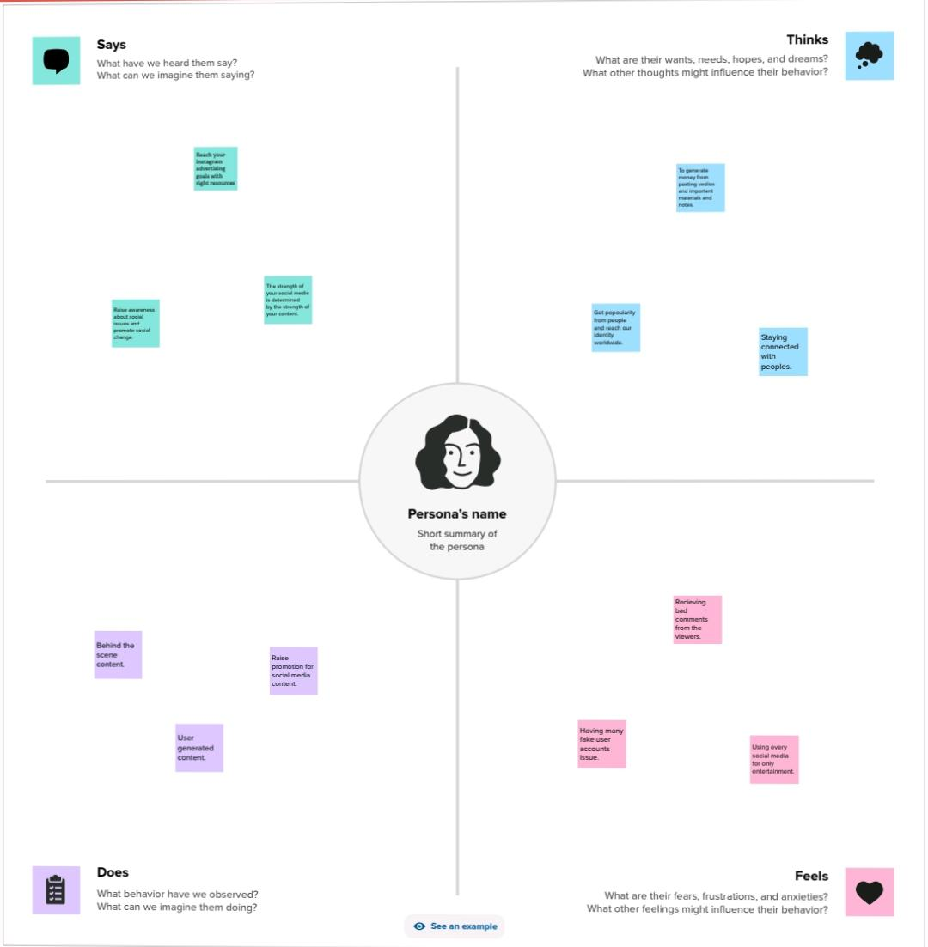
2.1Empathy Map

2.2 Ideation & Brainstorming Map
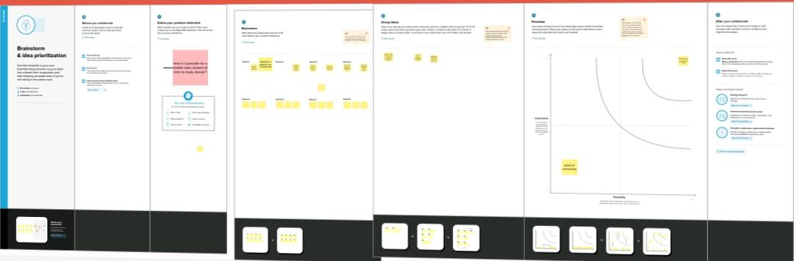

3.
4. ADVANTAGES & DISADVANTAGES

Advantages:
- Through this project we will learn about how to continue our studies in abroad.
- This helps to improve our educational knowledge.
DISADVANTAGES:
• The disadvantage in this project is struggle to reach the right place.

5. CONCLUSION
We started with canva editing app Then we create the social media post and download the post as png & pdf after that we applied the screen shot in this report.

